Lambdas and Functional Interface

- What is Lambdas: a Lambda (or lambda expression) is an anonymous function-a block of code that can be passed around and executed without being formally defined with a name
- ជា anonymous function ដែលយើងបង្កើតដោយមិនចាំបាច់ប្រើឈ្មោះ

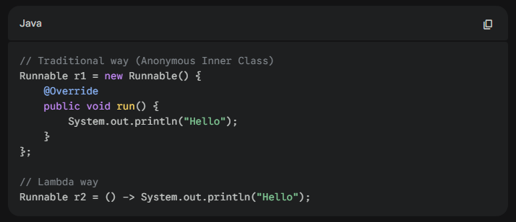

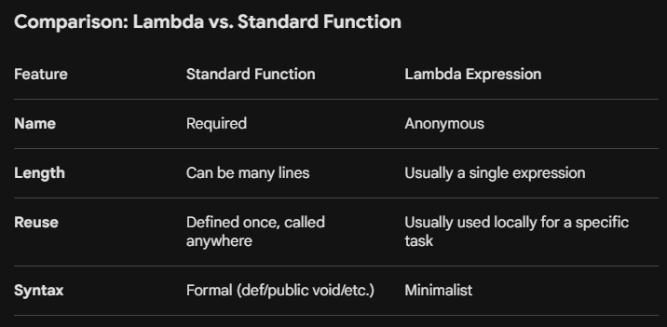

- Consumer Functional Interface

- that represents an operation that accepts a single input argument and returns no result.
វាជា Function ដែលទទួល Input ចំនួន មួយ និងមិនមាន Return មកវិញទេ គឺ void.
- Think of it as a "one-way" street: you give it something to work with, it performs an action (like printing, saving to a database, or logging), and then it’s finished. យើងគិតវាដូចជាផ្លូវមួយចឹង យើងធ្វើការ ដូចជា Printing (បោះពុម្ភហើយ វាមិនត្រូវការអ្វី បង្ហាញមកវិញទេ), រក្សាទុកទិន្នន័យទៅក្នុង Database ឬ មើល logging file)
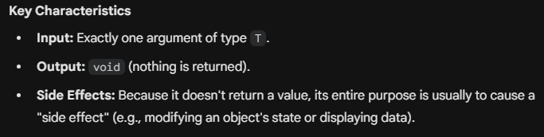

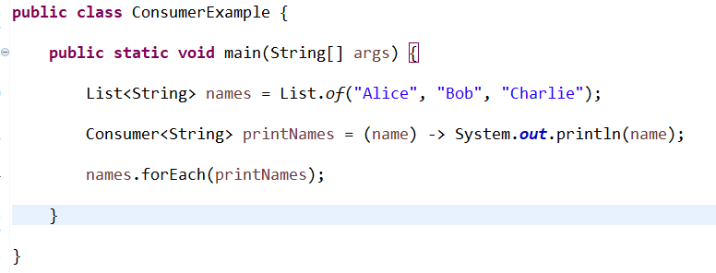

- Chainable Operation (andThen)

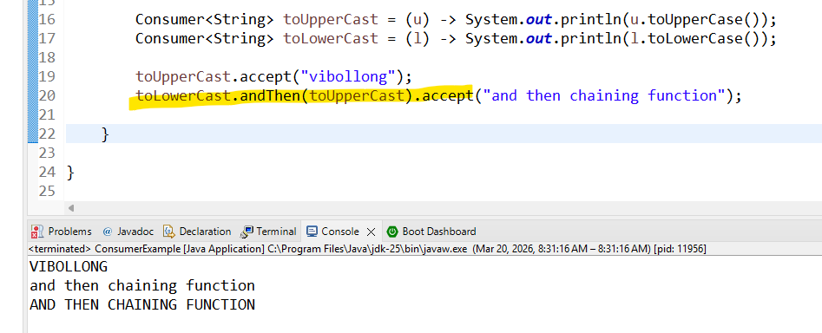

- BiConsumer Example
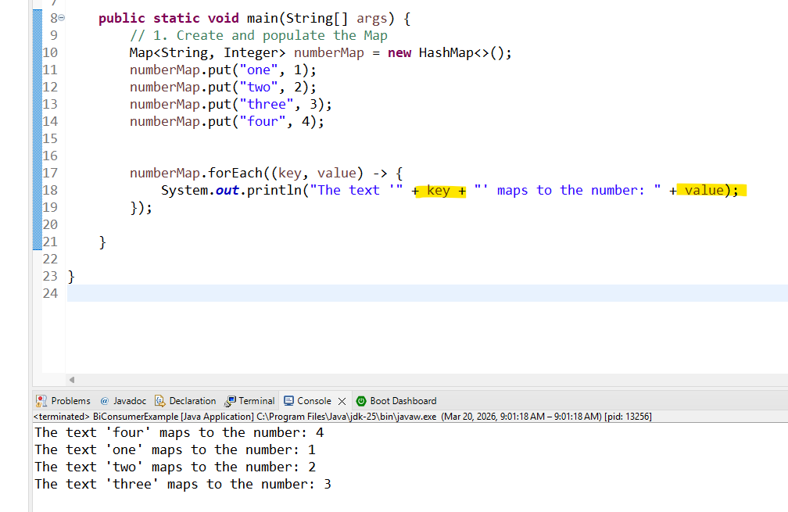

- Printing output

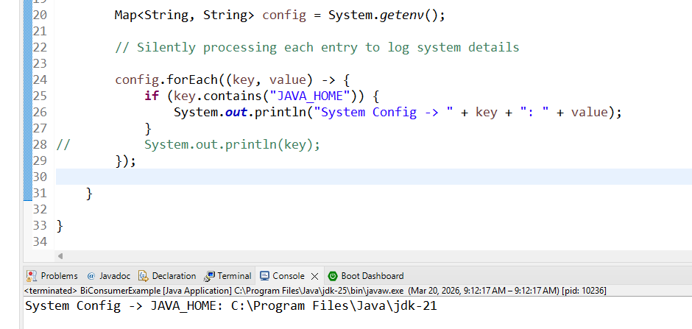

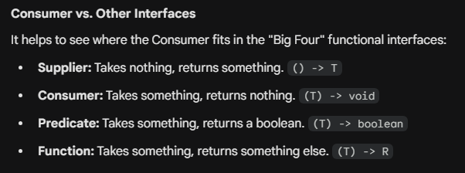

- Predicate: Return True or False

- Is a functional interface that represents a boolean-valued function of one argument.

In simpler terms, it is a "test" or a "filter."

You give it an input, and it returns either true or false. Its primary method is test(T t).

- ជាទូរទៅគេប្រើប្រាស់សម្រាប់ធ្វើការ Filter Method :
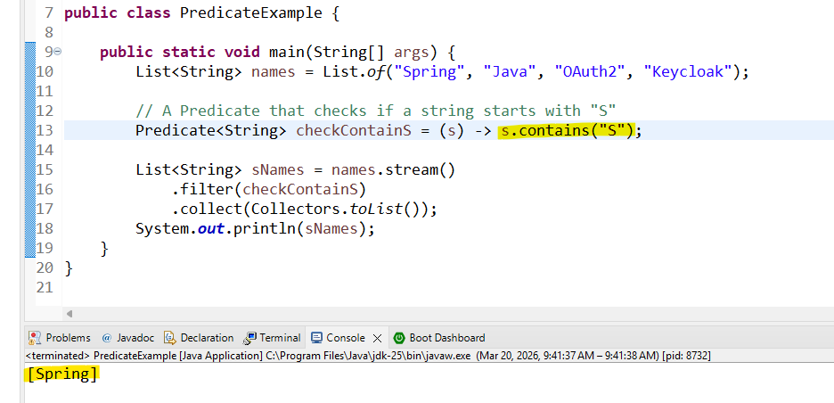

Example 2:
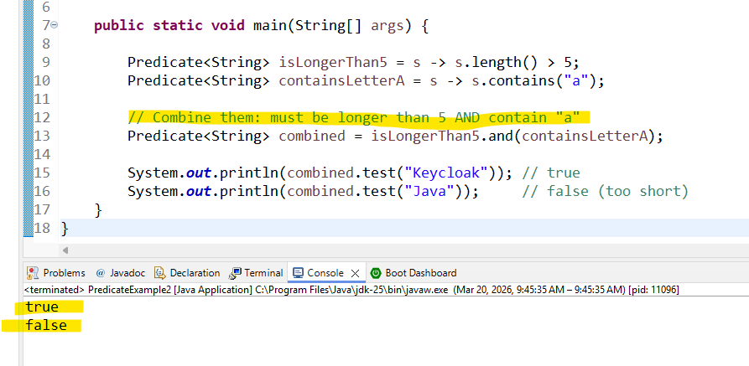

Interface | Input | Output | Analogy
Consumer | T | void | A black hole (eats data).
Supplier | None | T | A faucet (produces data).
Predicate | T | boolean | A bouncer (decides yes/no).
Function | T | R | A factory (transforms data).

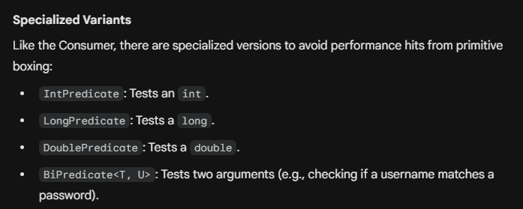

- Function<T, R> input type is T and return type is R

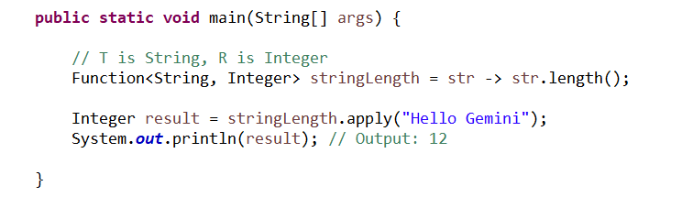
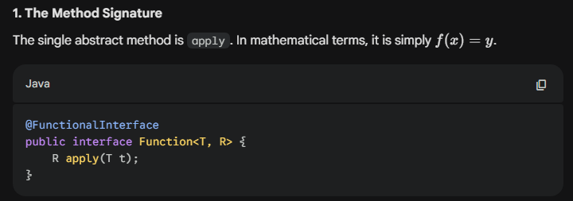

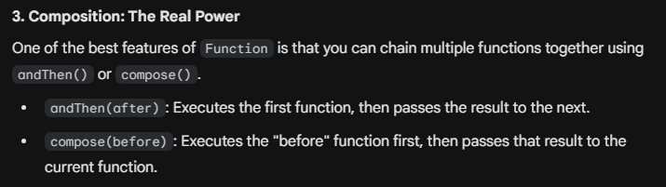

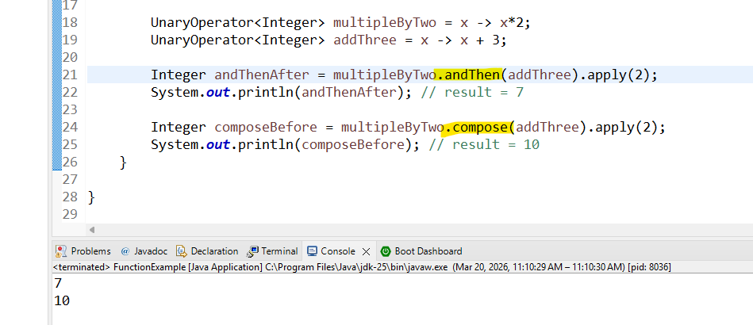

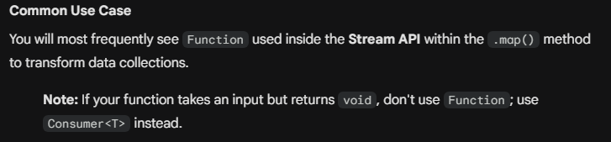

- UnaryOperatorExample: we use it when the input and output the same type

